Trajectory Recovery System: Stall Guidance for Inflight Loss of Control
Nikhileswar Badri
Florida Institute of Technology
Melbourne, FL
+1 669-234-6299
nbadri2014@my.fit.edu

ABSTRACT
This paper describes my contribution to the work for the In-flight Loss of Control (ILOC) that concentrates on flight STALL, guiding the pilot to recover from the stall and getting the flight back into its path. This system is named as Trajectory Recovery System (TRS).

Keywords
In-Flight Loss Of Control, Automation in aeronautics, Angle of Attack, Aerodynamically Stall, Human & Machine Interface, complexity in cockpit, Flight path recovery,.

INTRODUCTION
My work is to provide a visualization to the TRS system by providing a simulation prototype of the system using the VAPS XT simulation tool.
According to the NASA [12] research project examined that LOC-I accidents that occurred from 1999-2008, found that the leading casual factor of LOC-I accidents were because of human errors. The leading accidents in LOC-I is caused by the flight stall. The TRS aims to provide the pilot the information of angle of attack and guiding him during stall to recover the flight and set it back in flight path.
The flight stall occurs when the angle of attack reaches the critical angle of attack and at low speed (i.e. low thrust on the wings). The angle of attack is the difference between the pitch of the aircraft and the flight path angle. Angle of attack is required to generate the required lift to offset the aircraft’s load (weight). So, to avoid the wings from stall the pilot should have the track of the angle of attack and the thrust produced by the wings.
The complexity lies in integrating this system with the cockpit. The parameters from the cockpit need to be fed into this system. Information like AOA, Pitch, Roll, Yaw, air speed, altitude. This system is human-machine interface. Cockpit is complex system with many instruments and devices, pilot needs to be familiar with this system. This system is not a separate instrument but it could be programmed in the flight director to reduce the cockpit complexity.
To understand the system, TRS is simulated using VAPS XT and then trying to integrate it with the cockpit simulator present in the Human-Centered Design Institute in Florida Institute of Technology. This is human-centered approach as it follows purpose-to-means, because with the simulation flaws in the system can be found out before actually designing and integrating with the cockpit.

PROBLEM STATEMENT

Providing a visual solution i.e. visual design for the Trajectory Recovery system (TRS)
  - The visual design is created using the simulation tool named VAPS XT.
- Designing the prototype in the VAPS XT and simulating the design in it.

METHODOLOGY
This is a common work collaborating with Nicholas Kasdaglis, with his project on Trajectory Recovery System for In-Flight Loss of Control. His idea is to provide a alerting and guidance system for the pilot in the aero dynamical stall of the flight. In the stall situation the flight loses its lift and the flight drowns. To recover it from the stall, the pilot should lower down the nose of the flight, decrease the angle of attack and should increase the thrust in the wings i.e. increase the speed by increasing the power on the engines in the wings.
My contribution in this is to provide a visual design i.e. a simulation that shows the TRS work and integrating this design with the cockpit simulator.
To design the system I should first know the basics of the flight aerodynamics and the cockpit instruments like flight director and its working. So to understand these things I went through several documents that describes the flight parameters
The simulation is done in VAPS XT. VAPS XT is a flexible C++ object oriented human-machine interface (HMI) modeling tool. It provides a rapid prototyping, design, and deployment environment for the creation of 2D and 3D photorealistic graphical displays.
For my work on the VAPS XT, the tutorials of the VAPS XT were very useful in learning the tool, in a less time. The tutorials are very handy in learning the appropriate and proper usage of the tools [13].
The design is implemented within the flight director. Flight director is a guidance aid that is overlaid on the attitude indicator and shows the pilot of an aircraft the attitude required to follow a certain trajectory. The flight director computes and displays the proper pitch and bank angles required in order for the aircraft to follow a selected path [6].
In the VAPS XT, the design includes flight director with artificial horizon, pitch indicator, altitude indicator, air speed indicator, roll indicator, angle of attack, and the sliders to operate. Flight director is already pre-designed in the VAPS XT which contains the artificial horizon, pitch and roll. The altitude indicator, air speed indicator are created using the output object linear scale. The AOA indicator is designed using the circular scale output object.
This flight director is designed such a way that the function of pitch, roll, AOA and power (air speed) using the slider bars that are input objects in the VAPS XT.

Past and Present
The design is an iterative approach. There were several stages in development of the simulation. After the first stage it was checked by prof. Guy A. Boy, prof. Lucas A. Stephen and Nicholas Kasdaglis and the feedback, inputs were taken. These inputs and feedback were used for the further development.
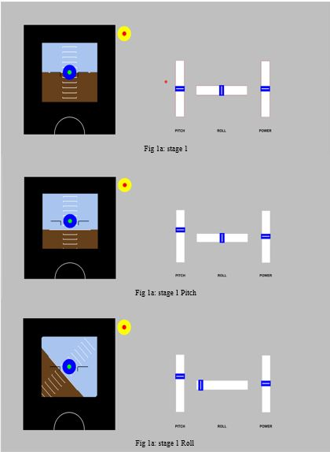
Fig 1: Stage 1 Design

The above fig 1 is the first stage of my design. It is a simple design representing the flight director, pitch slider, roll slider and power slider. The first stage is the simple implementation of TRS (Trajectory recovery system) mode. The circles in the artificial horizon guide the pilot to recover from the stall. This is checked with Dr. Boy, Dr. Lucas and Nicholas for the feedback and for further modification and inputs. Their feedback and inputs given rise to the next stage of the design.
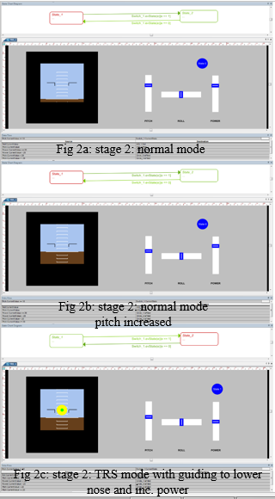
Fig 2.1: stage 2 Design

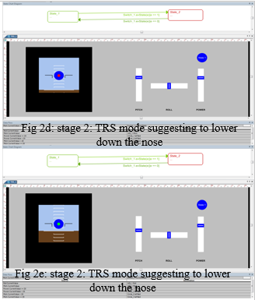
Fig 2.2: stage 2 Design
The second stage of the design is as shown in the fig 2. In this stage. I created two state:
- Normal state (fig 2a & fig 2b)
- TRS state (fig 2c – fig 2e )
The system is designed in a way that, the states are linked with a switch where the state 1 of the switch shows the state 1 of the system, i.e. normal mode. The state 2 of the switch shows the state 2 of the system i.e. the TRS (Trajectory Recovery System) mode. In the normal mode, the sliders are used to change the pitch, roll of the flight director. In the TRS mode, the pitch and roll should be matched with the desired level to make the middle circle from red to green. The power should be increased so that the yellow outer circle changes to blue color. When the inner circle is green and outer circle is blue the flight is recovered from the stall condition.
This design is reviewed by the professors and the further inputs / modification were taken, that led to the third design of the stage.

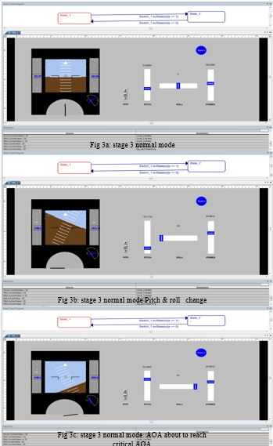
Fig 3.1: stage 3 Design
The stage 3 of the design is shown in fig 3. This has two stages that be switch between using switch. The guiding circles were fixed in between the pitch bars, but in this design the circle are free on the artificial horizon and not fixed between the pitch bars. In this design the slider have a digital values above them for the easy understanding. This also has the angle of attack measure and a slider for it, the airspeed scale and the altitude scale are added in this stage.

The states in this design are:
Normal state
TRS state
This is tested with the scenarios given by Nicholas:
- STATE 1: Normal State (fig 3a)
Pitch: 3
Roll: 0
Power appropriate for sustained flight
AOA 7
Display Normal
This scenario is shown in fig 3a.
- STATE 2: Aircraft Perturbation (fig 3b)
Trigger Event: The aircraft is perturbed for some reason (e.g. wake turbulence from an overtaking jet 1000 feet above)

The context is characterized by surprise
Pitch - 15
Roll+60
Power is inappropriate due to nose low attitude (speed is building)
AOA 5
Display Normal
This scenario is shown in fig 3b.
- STATE 3A: Aircraft Nearing Critical Angle of Attack (fig 3c)

TRIGGERING EVENT: Inappropriate and prolonged pilot input

CONTEXT: The context is chartered by disorientation
Pitch: + 30 degrees
Roll: Left 45 degrees
Power: low power setting
AOA of 11 with a critical AOA of 12 (point of stall)
This scenario is shown in fig 3c.
- STATE 3A: Aircraft Nearing Critical Angle of Attack (fig 3d)

TRIGGERING EVENT: Inappropriate and prolonged pilot input

CONTEXT: The context is chartered by disorientation
Pitch: + 30 degrees
Roll: Left 45 degrees
Power: low power setting
AOA of 11 with a critical AOA of 12 (point of stall)
This scenario is shown in fig 3d.
- STATE 3B TRS Activation State
(SAME AS 3A) (Fig 3e)

Display: TRS activated: removal or speed and altitude tapes and annunciation of "TRS MODE” to the left and right of PFD
Red diamond commanding: pitch and roll match”
Yellow ring indicate power too low and commanding increase in power
This scenario is shown in fig 3e.
- STATE 4: Normal State (fig 3f)
Pitch: 3
Roll: 0
Power appropriate for sustained flight
AOA 7
Display Normal
This scenario is shown in fig 3f.

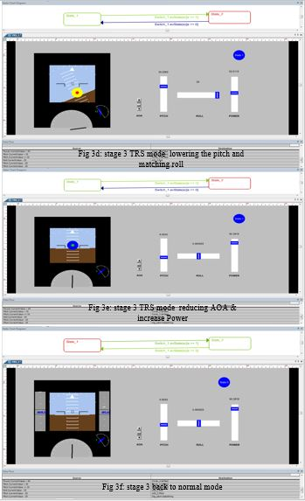
Fig 3.2: stage 2 Design
This design misses the TRS mode label at the side in TRS state. So, this design was reviewed and further medication were made. This the fourth stage of the design is shown in fig 4.

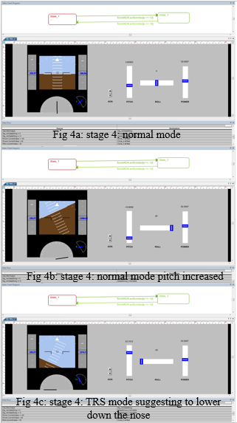
Fig 4.1: stage 4 Design
This model consists the automation of moving from normal state to TRS state which was controlled with a switch till previous model design. When the angle of attack reaches to 12 which is the critical angle of attack, the system changes from normal state to TRS state indicating that the flight is in stall mode and then it suggests the steps to get back to normal state. It automatically gets back to normal state when the AOA reaches to 7. The floating points in roll digital indicator are removed to have a precise value.

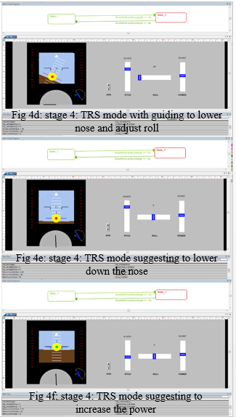
Fig 4.2: stage 4 Design
Other important development in this design is additon of the guiding lines for the roll control. Until previous model, the pilot may find difficult to roll back the flight and choosing the right direction to move the flight. These lines can help him to find the right directio easily. I have given a horizontal line passing the TRS guiding circle and a vertical line on the circle which always indicate the top of the flight. This guides the pilot for the roll adjustment. This model also have the TRS mode name in red on the sides replacing the altitude scale and air speed scale, that helps the pilot to concentrate on the artifical horizon without any distraction.

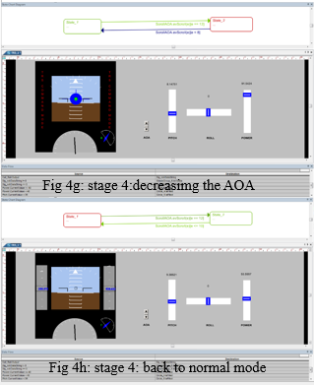
Fig 4.3: stage 4 Design
The fig 4a, fig 4b and fig 4c shows the different stages in thesting the design. The 6 testing secenarios were as before described above. The state flow chart above the above describes the condition for transistion between the states. It also projects the present state.

Future Work
I would like to integrate this system with the Boeing Cockpit simulator which is present in Human-Centered Design at Florida Institute of Technology, Melbourne, FL, to test its ability with the real life scenarios, and real flight challenges and get the feedback from the pilots of the simulator.
Before integrating with simulator I am trying to connect a joysticks for pitch, roll and joystick for throttle (power) to the system.
Working with simulator to find out the scenarios for In-flight Loss of Control, stall, and other parameters that are useful for my design. So, working with simulator can let me know the input parameters and output parameters for my designs that ae needed to be connected to the simulator to integrate the design.
This scenarios are dependent to the simulator implementation. The simulator works with software “Prepar3D” by Microsoft. The simulator description is taken from the sites of prepar3D [10] and x-plane [14].
Prepar3D is a simulation platform developed by Lockheed Martin. Offered for professional or academic purposes, the software allows users to create educational scenarios in the air, sea and on the ground. [9]
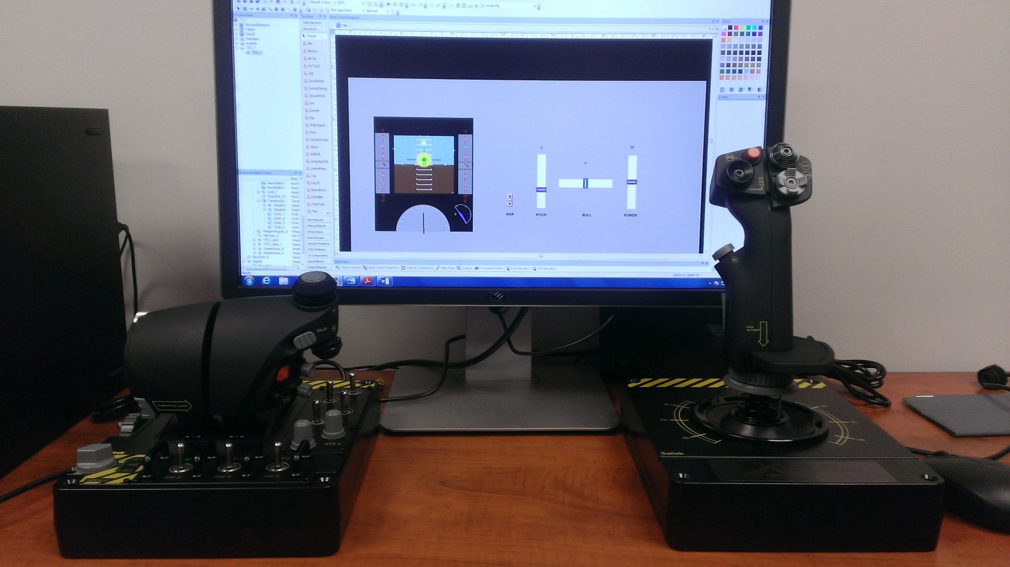
Fig 5: Saitek X-55 joystick with the design
The above diagram is representation about my future work in this project i.e. integration of the design with the joystick and the throttle controller. The controller I am supposed to be used is “Saitek X-55”. It features fully programmable drivers, enhanced 16-bit hall-effect sensors in the axis, and swappable springs for the joystick so you can dial in your preferred stick tension, twin lockable throttles and a friction adjustment that can be set on the fly.
The X-55 has 3 axis control, which can be used for pitch, roll, and yaw. The throttle controller has two throttle individually for both the engines. These controllers can be connected through USB to the system that I am my design is present.
First, before the design I need to understand the physics, parameters of the flight for which I went through several web pages, and papers.
The dynamics of the Boeing were taken from the Boeing site [4], the flight stall is understood from a paper on the stall training [3], the dynamics of the flight were clearly stated in a paper “Air Craft Pitch and Roll Dynamics” [5]. In this the dynamics of the flight (pitch and roll) on which my whole design is based on. The relation between the pitch, roll, yaw, air speed, angel of attack (AOA) weight of the flight, lift, drag all this key concepts of the flight dynamics are stated. The Yaw, roll moments and stability [11], this gives in the information on the yaw dynamics which includes the rudder, roll dynamics with the ailerons, the stability of the flight. The rudder and ailerons which are mostly used to maintain the stability of the flight in the air. The “Aerodynamics and Theory of flight” [2], gives an idea about the different critical situation of the flight like stall, spins. This also gives information on lift, weight, thrust, drag, angle of attack (AOA). The 737 landing techniques [1], is useful to know how to recover the flight in different scenarios with the parameters. This also gives the information on pitch and roll setting of the flight in the scenarios.

Data
Data acquisition is very important aspect for the project i.e. for the design, to work on the inputs and for the testing. It was agreed that the real values of the flight data or flight parameters are going to be obtained from the flight simulator. This data are to be acquired in the different angle of attack scenarios.
The data are pitch, roll, yaw, speed and others will be obtained from the simulator as real scenarios. This data is done in to a table and this is to be implemented in the TRS prototype design for the future work and also used for the testing purpose. This data will be very helpful for the future work on the design.

Wrapping Up
This project is for my Complexity Analysis class in Human-Centered Design. I applied the concepts of the complexity from the class in this design. The project itself is non-linear system, which has a lot of complexity in it and its implementation.
Complexity lies:
- In the physical models especially with real time scenarios, in simulator and its task.
The flight itself is a complex system, as it many physical parameters, cognition is always required to handle different situation. The flight simulator also has the same complexity in it, simulator is a virtual model of the flight cockpit which is used for training so same scenarios, parameters, and tasks are added to it.
- In integrating the TRS prototype design with the cockpit simulator [10] and with the joysticks [14] (Saitek X-55)
The cockpit has many parameters. To integrate the prototype design is going to be a complex issue. The required parameters from the cockpit are extracted and fed to the design as inputs and the output from the design need to be given back to the cockpit. This is like a feedback loop. In the case of integration with joystick, the joystick controls should be connected with the design and the joystick movements should be programmed to control the design.
- In making the pilot familiar with the system
The cockpit consists many system with which the pilots always feel complex until he/she becomes familiar in using them. So this design is going to be new to the pilot and he feels complex when he work with this design at starting stages. Eventually when we make him/her comfortable with this system, it is familiar and he/she works good with the design. The work and use of the design should be explained to pilot very clearly and pilot should be trained to use this in different scenarios.
- In visualization of the design
Creating the design is complex, because the creating a design for a complex system is complex. The design has many components in it, linking this component within them is a complex. The designer of the system feels less complex because the designer knows links and objects that are linked and other may feel complex and may require more time to analyze the design components.
- In-Flight Loss of control (ILOC)
The ILOC itself is a complex issue. ILOC includes many scenarios like, aero dynamical stall, icing, flight controls/system/structure, microburst, crew disorientation. So, complexity lies to knowing reason for the ILOC because for every scenarios there are separate procedures to be followed to avoid the ILOC situation. Each scenario is complex in its way.

ACKNOWLEDGMENTS
I thankful to Dr. Guy A. Boy, Dr. Lucas A. Stephen and Nicholas Kasdaglis for their support and help in my project. They were very handy with providing the required documents, inputs and feedback for the TRS design.

CONCLUSION
I conclude this report, this TRS design can be used as an alerting and guiding system for the pilot in the aerodynamic stall situation. This will guide the pilot with procedures to recover from the stall. The red circle at center will guide the pilot to lower the flight nose till nose reach the preferred pitch (i.e. red inner ring changes to blue). The yellow outer ring indicates to increase the power that help the flight to get the lift, the yellow ring turns to blue when it acquires required power to get the lift to recover the flight from the stall. I would like to extend this design to the flight simulator and test this with the all possible scenarios. With this I can move to integrate this system with Boeing flights which can be useful in real time situation.

REFERENCES
- 737 Landing Technique: http://www.b737.org.uk/landingtechnique.htm
- Aerodynamics and Theory of Flight: http://www.langleyflyingschool.com/Pages/CPGS+4+Aerodynamics+and+Theory+of+Flight+Part+1.html
- An Evaluation of Several Stall Models for Commercial Transport Training: http://www.faa.gov/pilots/training/media/Evaluation_of_Stall_Models_for_Training.pdf
- BOEING AERO 12 Angle of Attack: http://www.boeing.com/commercial/aeromagazine/aero_12/attack_story.html
- Eugene Lavretsky. “Aircraft Pitch and Roll Dynamics”, May 01, 2005: http://www.cds.caltech.edu/archive/help/uploads/wiki/files/136/Aircraft_Pitch_Roll_Dynamics.pdf
- Flight Director: http://www.skybrary.aero/index.php/Flight_Director

- Nicholas Kasdaglis, “ Trajectory Recovery System: Angle of Attack Guidance for Inflight Loss of Control”
- Nicholas Kasdaglis, “Trajectory Recovery system AIM/ODM Solutions”.
- Prep3D information: http://en.wikipedia.org/wiki/Lockheed_Martin_Prepar3D
- Prepar3D simulator: http://www.prepar3d.com/product-overview/
- Roll and Yaw Moments and Stability: http://www.dept.aoe.vt.edu/~lutze/AOE3134/YawMoment.pdf
- S. Jacobson. "Aircraft loss of control causal factors and mitigation challenges," in Anonymous 2010, Available: http://dx.doi.org/10.2514/6.2010-8007. DOI: doi:10.2514/6.2010-8007.
- VAPS XT: http://www.presagissupport.com/training/Videos/videos-all.html
- X-plane: http://www.x-plane.com/desktop/meet_x-plane/

